# Introduction to rehabilitation concepts for mine voids

Rehabilitation concepts for stabilising mine pits in the Latrobe Valley have been explored by both government and declared mine licensees. This fact sheet series focuses on general rehabilitation concepts noting that each mine site must develop a site-specific plan (called a Declared Mine Rehabilitation Plan) for community consultation and regulatory approval. Under the *Mineral Resources (Sustainable Development) Act 1990*, the sites must be left safe, stable and sustainable. Key hazards addressed by these concepts are detailed in the MLRA Key Hazards fact sheet series, with terminology specific to mine rehabilitation in Victoria defined in the [MLRA Vocabulary](https://www.mineland.vic.gov.au/learn/vocabulary/) (updated regularly).

The rehabilitation concepts discussed in this series include dry void, partial lake, full lake, and full lake interconnected.

Once sites are safe, stable, and sustainable, future land uses can be determined. The responsibility for implementing these uses will likely be shared among multiple stakeholders, including state and local governments, licensees, and the private sector, with input from the community and Traditional Owners.

After mining operations conclude, the site transitions into the closure and rehabilitation phase. Final landforms are designed to mitigate long-term hazards such as [block slides](https://www.mineland.vic.gov.au/news/key-terminology-understanding-the-language-of-mine-rehabilitation/), [floor heave](https://www.mineland.vic.gov.au/news/key-terminology-understanding-the-language-of-mine-rehabilitation/) and fire. Licensees are required to conduct technical studies, evaluate risks and outline mitigation measures to address any identified issues with the proposed end landform.

# Findings to date

The Hazelwood Mine Fire Inquiry (HMFI) considered six rehabilitation approaches. The Board of Inquiry was persuaded by the expert evidence provided at the time that a waterbody-based option was the most viable rehabilitation approach for each void. This finding was based on the ongoing risks of fire and instability that would need to be managed after mining ceased.

# Rehabilitation concept: partial pit lake

A partial pit lake is a body of water established within a mine void where the void has been partially flooded. Rehabilitating the Latrobe Valley declared mines as partial pit lakes would require extensive earthworks to maintain batter stability, weight balance, and minimise coal exposure (which reduces the fire risks). This landform design would involve partially filling the voids with large volumes of material, supplemented by water. Where these materials would come from is uncertain, the volume of material required is unlikely to be available within the mine license areas, or in the Latrobe Valley and transport of these materials from elsewhere would present environmental and amenity impacts and logistical challenges.

For this landform option, the water level would not reach the top of the void, leaving steep, exposed mine batters. These would need to be reprofiled and covered with overburden, topsoil, and vegetation. Ongoing maintenance of this soil cover would be necessary to control erosion and manage risks such as coal exposure or fire (Figure 1). At the lake edges, entry and exit points would be necessary for safety and maintenance. It is also likely that beaching zones would need to be established at the shoreline.

Given the exposed reprofiled mine batters, horizontal bores will likely be required to drain water from behind the batters to maintain stability.

Rain, surface water, and groundwater inflows would likely require ongoing management to keep the pit stable and maintaining water levels. Water treatment may be necessary.

Ongoing monitoring and maintenance are crucial to ensuring the safety, stability, and sustainability of a partial pit lake. These requirements are expected to be more demanding compared to a full pit lake given that ground water may still need to be pumped out (to retain weight balance) and significant work may be required to manage batters ongoing. As a result, access to the pit and the surrounding land for alternative uses may be limited.

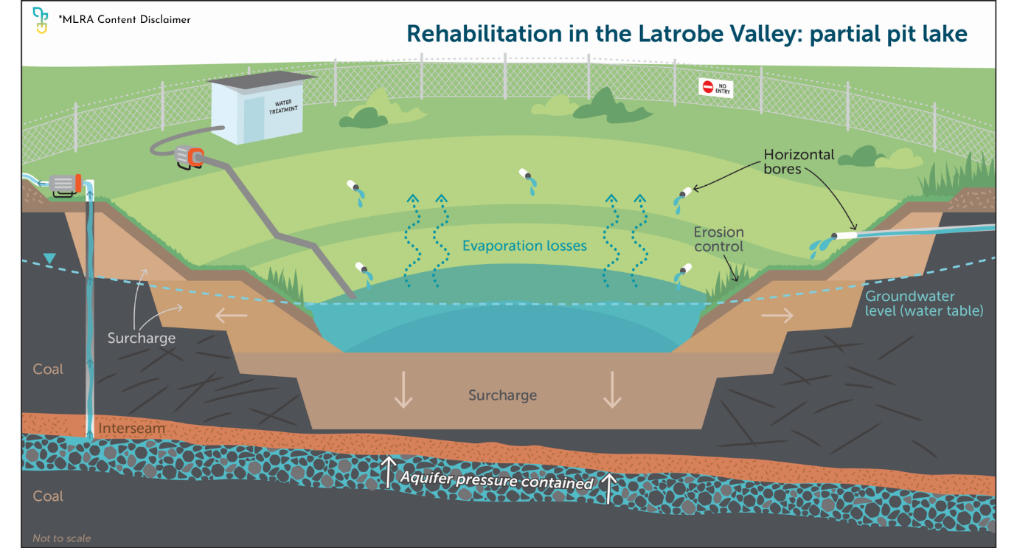

Figure 1

## A partial pit lake over the long term

We live in an ever changing natural and social environment. A partial pit lake is subject to natural and human-induced changes, requiring significant and ongoing management, similar to a dry void. The slopes are prone to erosion, and the risk of [block slides](https://www.mineland.vic.gov.au/news/key-terminology-understanding-the-language-of-mine-rehabilitation/) remain. [Block slides](https://www.mineland.vic.gov.au/news/key-terminology-understanding-the-language-of-mine-rehabilitation/) could expose coal, increasing the risk of fire and long-term instability (Figure 2). Managing a partial pit lake over time would require extensive infrastructure and active intervention to maintain stability. This may include managing surface drains, pumping to control aquifer pressure, handling in-pit water, maintaining horizontal drains, repairing erosion, and preserving vegetative cover. Continuous monitoring for stability may also be essential. These ongoing activities would likely restrict access to the pit and surrounding land for other uses.

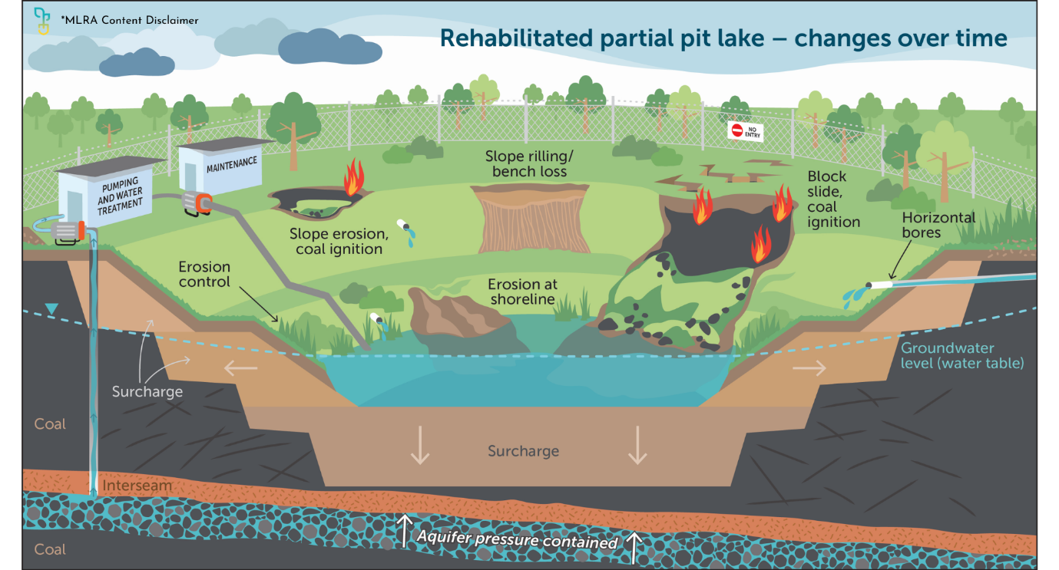

Figure 2

If you are reading a printed copy, you can find all hyperlinks by visiting [www.mineland.vic.gov.au](http://www.mineland.vic.gov.au) and searching for the relevant topic.

Disclaimer:

This content provides the MLRA's high-level overview of aspects of mine rehabilitation in the Latrobe Valley. It does not reflect the opinions, pre-empt decisions or policies of Resources Victoria, mine licensees or any other government department.  The information was accurate to the best of the MLRA's knowledge at the time of publication and is intended to inform the community, stakeholders and Traditional Owners.

 @MLRAuthority  Facebook.com/MLRAVictoria  MLRAuthority