# Introduction to rehabilitation concepts for mine voids

Rehabilitation concepts for stabilising mine pits in the Latrobe Valley have been explored by both government and declared mine licensees. This fact sheet series focuses on general rehabilitation concepts noting that each mine site must develop a site-specific plan (called a Declared Mine Rehabilitation Plan) for community consultation and regulatory approval. Under the *Mineral Resources (Sustainable Development) Act 1990*, the sites must be left safe, stable and sustainable. Key hazards addressed by these concepts are detailed in the MLRA Key Hazards fact sheet series, with terminology specific to mine rehabilitation in Victoria defined in the [MLRA Vocabulary](https://www.mineland.vic.gov.au/learn/vocabulary/) (updated regularly).

The rehabilitation concepts discussed in this series include dry void, partial lake, full lake, and full lake interconnected.

Once sites are safe, stable, and sustainable, future land uses can be determined. The responsibility for implementing these uses will likely be shared among multiple stakeholders, including state and local governments, licensees, and the private sector, with input from the community and Traditional Owners.

After mining operations conclude, the site transitions into the closure and rehabilitation phase. Final landforms are designed to mitigate long-term hazards such as [block slides](https://www.mineland.vic.gov.au/news/key-terminology-understanding-the-language-of-mine-rehabilitation/), [floor heave](https://www.mineland.vic.gov.au/news/key-terminology-understanding-the-language-of-mine-rehabilitation/) and fire. Licensees are required to conduct technical studies, evaluate risks and outline mitigation measures to address any identified issues with the proposed end landform.

# Findings to date

The Hazelwood Mine Fire Inquiry (HMFI) considered six rehabilitation approaches. The Board of Inquiry was persuaded by the expert evidence provided at the time that a waterbody-based option was the most viable rehabilitation approach for each void. This finding was based on the ongoing risks of fire and instability that would need to be managed after mining ceased.

# Rehabilitation concept: full pit lake

A pit lake is a body of water established within a mine void that has been intentionally or unintentionally flooded.

With pit lakes, areas above the final water level would likely be reprofiled and covered with overburden, topsoil, and vegetation to prevent erosion and reduce coal exposure (Figure 1). Maintaining these upper slopes and the surrounding areas near the water level would be necessary to maintain stability and minimise long-term impacts.

Where public access is included in the proposed end land use, rehabilitated pit lakes may feature shallow beach areas to facilitate safe recreational access. Additionally, access tracks could be incorporated into the final landform design to support usability and accessibility.

Establishing pit lakes would require large volumes of water and the maintenance of water levels over time. Furthermore, risks must be identified and assessed. Licensees proposing pit lakes are required to conduct technical studies to evaluate risks and outline mitigation measures to address any identified issues.

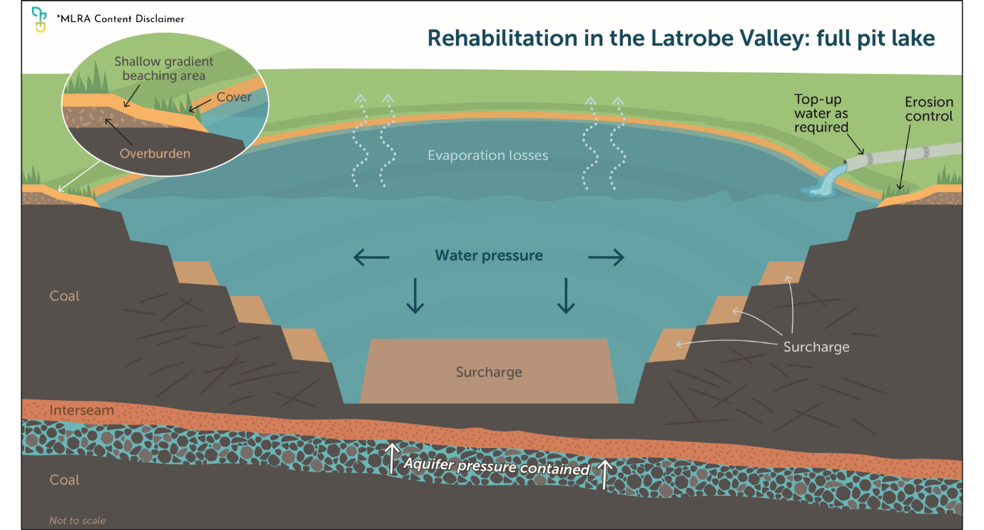

Figure

## A full pit lake over the long term

We live in an ever changing natural and social environment. A full pit lake is influenced by natural changes and human interactions, with erosion and water quality variations being common long-term processes. These factors will likely require periodic intervention, such as adding 'top-up' water to compensate for evaporation (Figure 2). The HMFI and current understanding indicates that full pit lakes are likely to reduce the risk of ground instability and associated safety and infrastructure risks.

While full pit lakes are likely to reduce the number of active controls compared to dry voids or partial pit lakes, ongoing monitoring and maintenance will still be necessary, albeit potentially to a lesser extent. Monitoring and maintenance activities will still be required. Some of these activities may include but are not limited to vegetation cover maintenance and water level and water quality management. Importantly, full pit lakes may offer more opportunities for public access and other future uses.

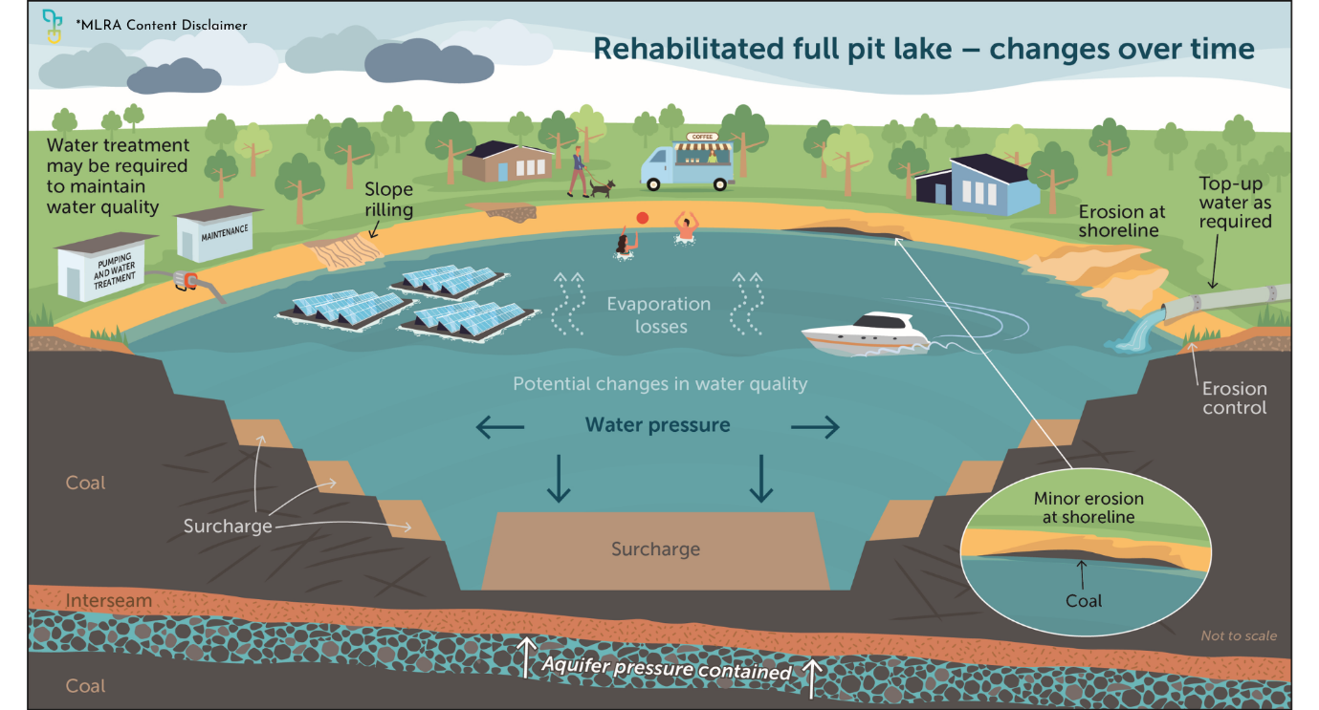

Figure : Potential end land uses for illustrative purposes only; significant studies would be required to confirm feasibility.

If you’re reading a printed copy, you can find all hyperlinks by visiting [www.mineland.vic.gov.au](http://www.mineland.vic.gov.au) and searching for the relevant topic.

Disclaimer:

This content provides the MLRA's high-level overview of aspects of mine rehabilitation in the Latrobe Valley. It does not reflect the opinions, pre-empt decisions or policies of Resources Victoria, mine licensees or any other government department.  The information was accurate to the best of the MLRA's knowledge at the time of publication and is intended to inform the community, stakeholders and Traditional Owners.

 @MLRAuthority  Facebook.com/MLRAVictoria  MLRAuthority