# Introduction to rehabilitation concepts for mine voids

Rehabilitation concepts for stabilising mine pits in the Latrobe Valley have been explored by both government and declared mine licensees. This fact sheet series focuses on general rehabilitation concepts noting that each mine site must develop a site-specific plan (called a Declared Mine Rehabilitation Plan) for community consultation and regulatory approval. Under the *Mineral Resources (Sustainable Development) Act 1990*, the sites must be left safe, stable and sustainable. Key hazards addressed by these concepts are detailed in the MLRA Key Hazards fact sheet series, with terminology specific to mine rehabilitation in Victoria defined in the [MLRA Vocabulary](https://www.mineland.vic.gov.au/learn/vocabulary/) (updated regularly).

The rehabilitation concepts discussed in this series include dry void, partial lake, full lake, and full lake interconnected.

Once sites are safe, stable, and sustainable, future land uses can be determined. The responsibility for implementing these uses will likely be shared among multiple stakeholders, including state and local governments, licensees, and the private sector, with input from the community and Traditional Owners.

After mining operations conclude, the site transitions into the closure and rehabilitation phase. Final landforms are designed to mitigate long-term hazards such as [block slides](https://www.mineland.vic.gov.au/news/key-terminology-understanding-the-language-of-mine-rehabilitation/), [floor heave](https://www.mineland.vic.gov.au/news/key-terminology-understanding-the-language-of-mine-rehabilitation/) and fire. Licensees are required to conduct technical studies, evaluate risks and outline mitigation measures to address any identified issues with the proposed end landform.

# Findings to date

The Hazelwood Mine Fire Inquiry (HMFI) considered six rehabilitation approaches. The Board of Inquiry was persuaded by the expert evidence provided at the time that a waterbody-based option was the most viable rehabilitation approach for each void. This finding was based on the ongoing risks of fire and instability that would need to be managed after mining ceased. The inquiry identified that a dry void was not a viable option “*due to the need for ongoing landform stability works, such as dewatering in perpetuity.”*

The Latrobe Valley Regional Rehabilitation Strategy (LVRRS) [[Amendment](https://resources.vic.gov.au/projects/lvrrs) 2023](https://resources.vic.gov.au/projects/lvrrs) explained that dry voids would require a high level of active management including ongoing groundwater pumping to manage stability concerns. It noted that a dry void is considered the most susceptible to variabilities in ground conditions and to changes over time that could result in uncontrolled ground movements (i.e., collapses or ‘failures’). Additionally, unless the voids were covered by water, coal fires would remain a risk.

These reports highlighted the risks and challenges associated with constructing and maintaining a dry void rehabilitation concept in the long term.

# Rehabilitation concept: dry void

A rehabilitated mine that does not contain amounts of water is referred to as a *dry void*. With this option, the mine pit is partially filled with solid fill material (e.g., gravel, sand, clay – also called “overburden”) and is rehabilitated as a dry lowered landform. Rehabilitating the Latrobe Valley declared mines as dry voids would require extensive earthworks to maintain batter stability (e.g., with earthen buttresses) weight balance (e.g., with surcharges to provide a counterweight to groundwater pressures) and minimise coal exposure (e.g., with clay capping) reducing fire risks (Figure 1). Significant volumes of material would be required to stabilise the voids and cover the exposed coal. Where these materials would come from is uncertain, the volume of material required is unlikely to be available within the mine license areas, or in the Latrobe Valley and transport of these materials from elsewhere would present environmental and amenity impacts.

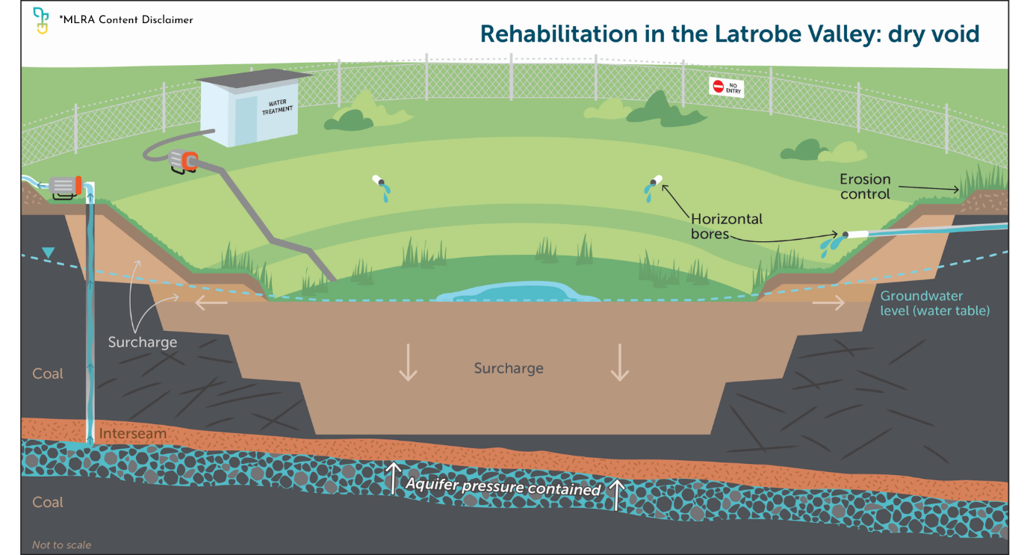

Figure

## A dry void over the long term

We live in an ever changing natural and social environment. The presence of dry voids in the Latrobe Valley would necessitate extensive ongoing monitoring and maintenance into perpetuity.

The slopes are prone to erosion, and the risk of [block slides](https://www.mineland.vic.gov.au/news/key-terminology-understanding-the-language-of-mine-rehabilitation/) remain. [Block slides](https://www.mineland.vic.gov.au/news/key-terminology-understanding-the-language-of-mine-rehabilitation/) could expose coal, increasing the risk of fire, long-term instability and impact on surrounding surface water features (Figure 2).

Managing a dry void over time would require extensive infrastructure and active maintenance. This includes, but is not limited to, managing surface drains, pumping to control aquifer pressure, handling of in-pit water, surface water and groundwater levels and quality analysis, maintaining horizontal drains, maintaining flood levees, repairing and replacing material lost through erosion, managing fire risk and preserving vegetative cover. Continuous monitoring for stability would also be essential. These ongoing activities would likely restrict access to the pit and surrounding land for other uses.

For the reasons outlined in this fact sheet the MLRA considers that dry voids are not a viable option for the long-term safety, stability, and sustainability of the Latrobe Valley declared mine sites.

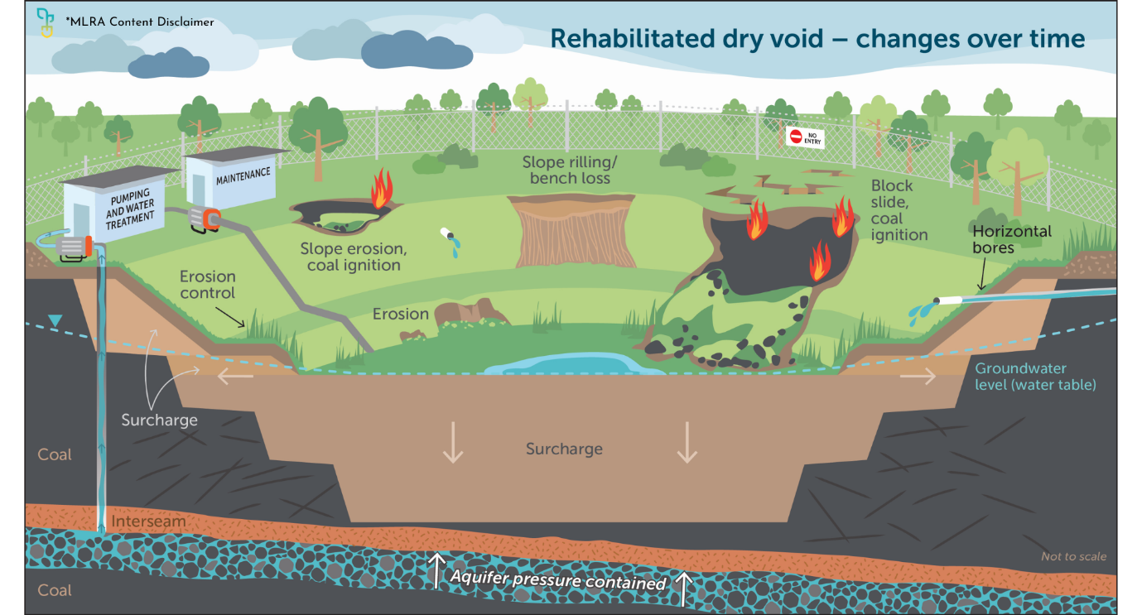

Figure

If you’re reading a printed copy, you can find all hyperlinks by visiting [www.mineland.vic.gov.au](http://www.mineland.vic.gov.au) and searching for the relevant topic.

Disclaimer:

This content provides the MLRA's high-level overview of aspects of mine rehabilitation in the Latrobe Valley. It does not reflect the opinions, pre-empt decisions or policies of Resources Victoria, mine licensees or any other government department.  The information was accurate to the best of the MLRA's knowledge at the time of publication and is intended to inform the community, stakeholders and Traditional Owners.

## 

 @MLRAuthority  Facebook.com/MLRAVictoria  MLRAuthority