# Key hazards series: Fire

The Latrobe Valley declared mines must be rehabilitated to a state which is safe, stable, sustainable and suitable for proposed post-mining land uses. Mitigating hazards, both during operations and rehabilitation, is a key responsibility of mine licensees.

A hazard is any source of potential harm, damage, or adverse health effects on individuals, assets, or the environment.

This fact sheet is part of the Key Hazards series which addresses hazards such as block sliding, floor heave and fire. Key terminology is defined in the MLRA Vocabulary on our website.

## Fire and coal

Coal, a combustible material, becomes a potential fire hazard when exposed through mining. Fire is a significant hazard in coal mines globally.

## Sources of ignition

Coal fires can be ignited by various sources, including:

* Bushfires: Blown embers (spotting) can ignite exposed coal in open-cut mines.
* Vehicle Heat: Engines and exhaust systems may become hot enough to ignite coal.
* Spontaneous Combustion: Coal can self-heat under the right conditions, leading to ignition. Factors required for spontaneous combustion include:
* Coal Composition: Certain chemical properties increase combustibility. Particle Size: Smaller particles expose more surface area to oxygen and moisture, making them more prone to ignition. Large, compact coal surfaces are less likely to ignite.
* Oxygen and Moisture: Both play critical roles in the self-heating process.
* Human Activity: Intentional or accidental actions can ignite exposed coal.
* Lightning Strikes: Direct strikes on exposed coal can cause fires.

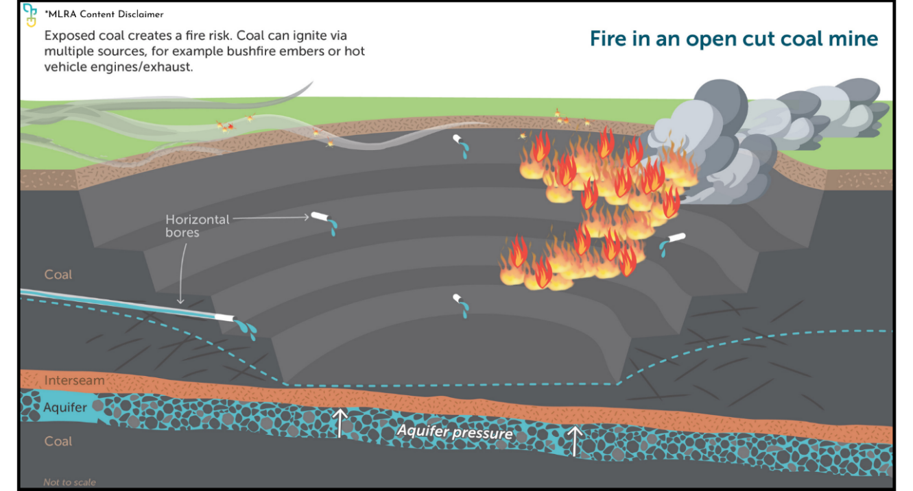

*Figure 1*

Managing fire risks

Common operational measures for managing fires in coal mines include but are not limited to:

* Weather and Bushfire Monitoring: Active management plans based on fire danger ratings, which may include:
* Utilising sprinkler systems around the mine (figure 2)
* Suspending mining activities during extreme weather conditions.
* Hotspot Management: Addressing areas prone to self-heating by:
* Digging out and remediating loose or warm coal areas, then sealing them with clay to block oxygen and moisture
* Monitoring known or potential self-heating zones
* Vehicle Modifications: Reducing ignition risks by modifying exhaust systems, using washdown points, and ensuring vehicles are safe for coal environments
* Coal Covering: Placing overburden over exposed coal as mining operations in that area are completed

A fire hydrant spraying water on a circular road



Figure 2

Rehabilitating coal mines offers an opportunity to minimise fire risks associated with exposed coal. Rehabilitation options aim for passive fire mitigation, focusing on covering coal to limit ember attack and the ingress of oxygen and moisture. For further information see the MLRA Rehabilitation Concepts fact sheet series.

If you’re reading a printed copy, you can find all hyperlinks by visiting www.mineland.vic.gov.au and searching for the relevant topic.

## Disclaimer:

This content provides the MLRA's high-level overview of aspects of mine rehabilitation in the Latrobe Valley. It does not reflect the opinions, pre-empt decisions or policies of Resources Victoria, mine licensees or any other government department. The information was accurate to the best of the MLRA's knowledge at the time of publication and is intended to inform the community, stakeholders and Traditional Owners.

 @MLRAuthority  Facebook.com/MLRAVictoria  MLRAuthority