# Key hazards series: Block Sliding

The Latrobe Valley declared mines must be rehabilitated to a state which is safe, stable, sustainable and suitable for proposed post-mining land uses. Mitigating hazards, both during operations and rehabilitation, is a key responsibility of mine licensees.

This fact sheet is part of the Key Hazards series which addresses hazards such as block sliding, floor heave and fire. Key concepts are explained in the MLRA Rehabilitation Concepts fact sheet series, with terminology defined in the MLRA Vocabulary on our website.

# Block sliding

Ground movement in the Latrobe Valley declared mines can occur for various reasons, with block sliding being a significant risk to the stability of mine batters and land near the void edges. Under certain conditions, large coal blocks can slide into the void, compromising stability.

## How can blocks slide?

In the Latrobe Valley, clay and silt layers, known as interseams, lie between coal layers and create surfaces along which coal blocks can slide. Water build-up behind the batters in coal joints and cracks, caused by heavy rainfall or water from nearby watercourses, applies sideways pressure (figure 1) If unmanaged, this pressure can force the blocks to slide along the interseam into the void, causing the batter to slump into the pit (figure 2)

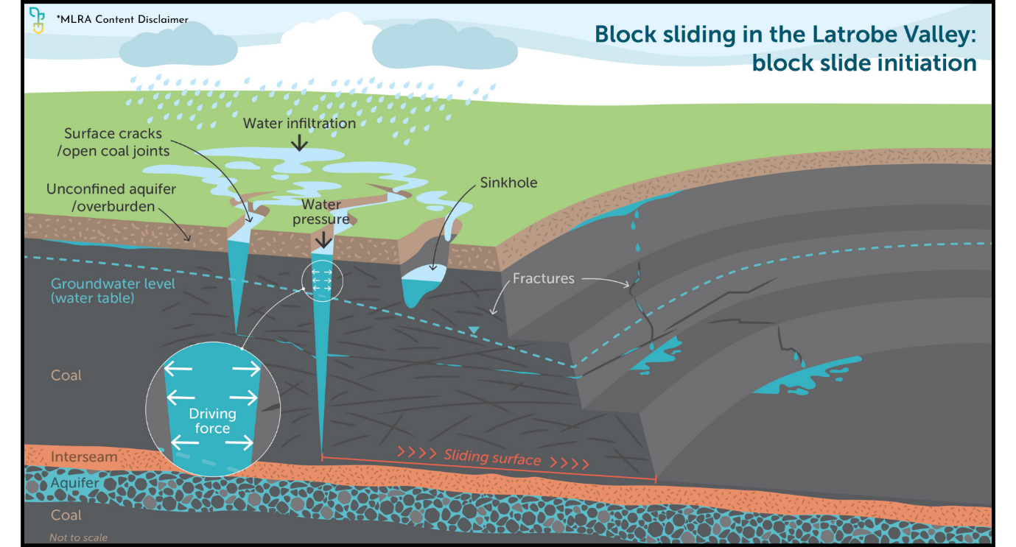

Figure 1

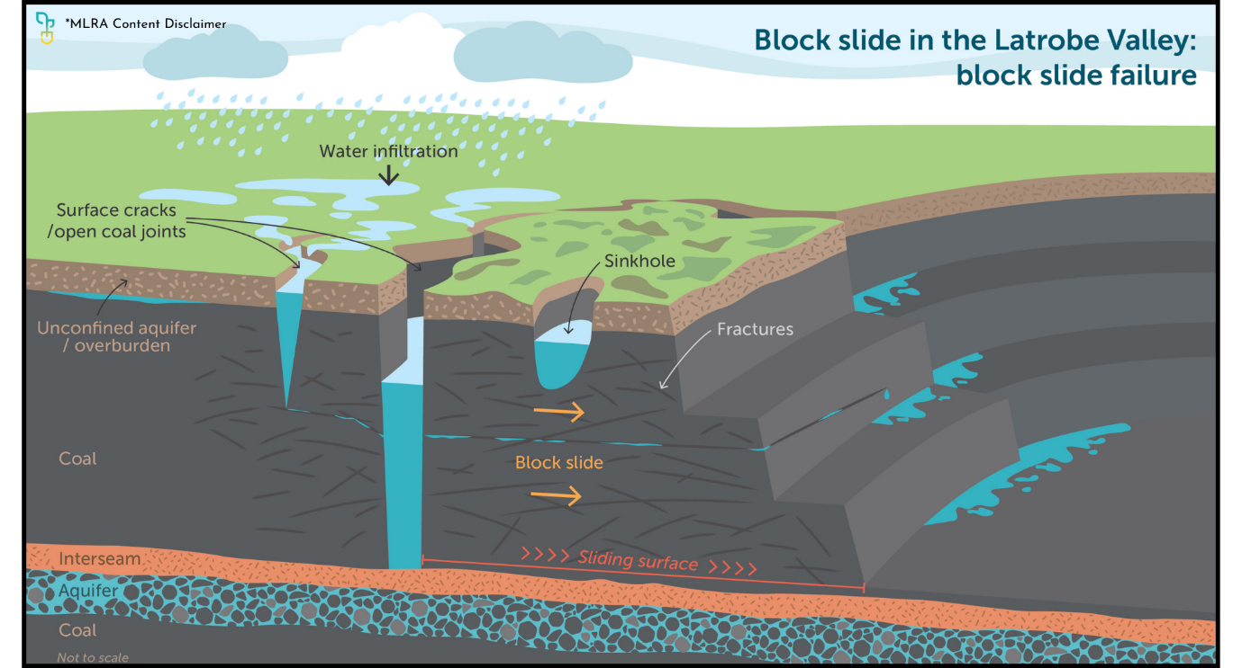

Figure 2

## How can slides be prevented?

Common operational measures aimed at reducing the water from behind the batters (figure 3) include, but are not limited to:

* Horizontal Drains: Boring horizontal drains into batters to release water and prevent build-up behind coal batters.
* Surface Water Diversion: Installing drains and culverts to redirect surface water away from cracks and joints.

For rehabilitation, passive mitigation strategies are preferred. See the MLRA Rehabilitation Concepts fact sheet series for additional information. Measures being considered include but are not limited to:

* Overburden Placement: Strategically placing overburden in the pit to buttress mine batters.
* Pit Lakes: Using water to create a pit lake, which provides additional pressure to batters.

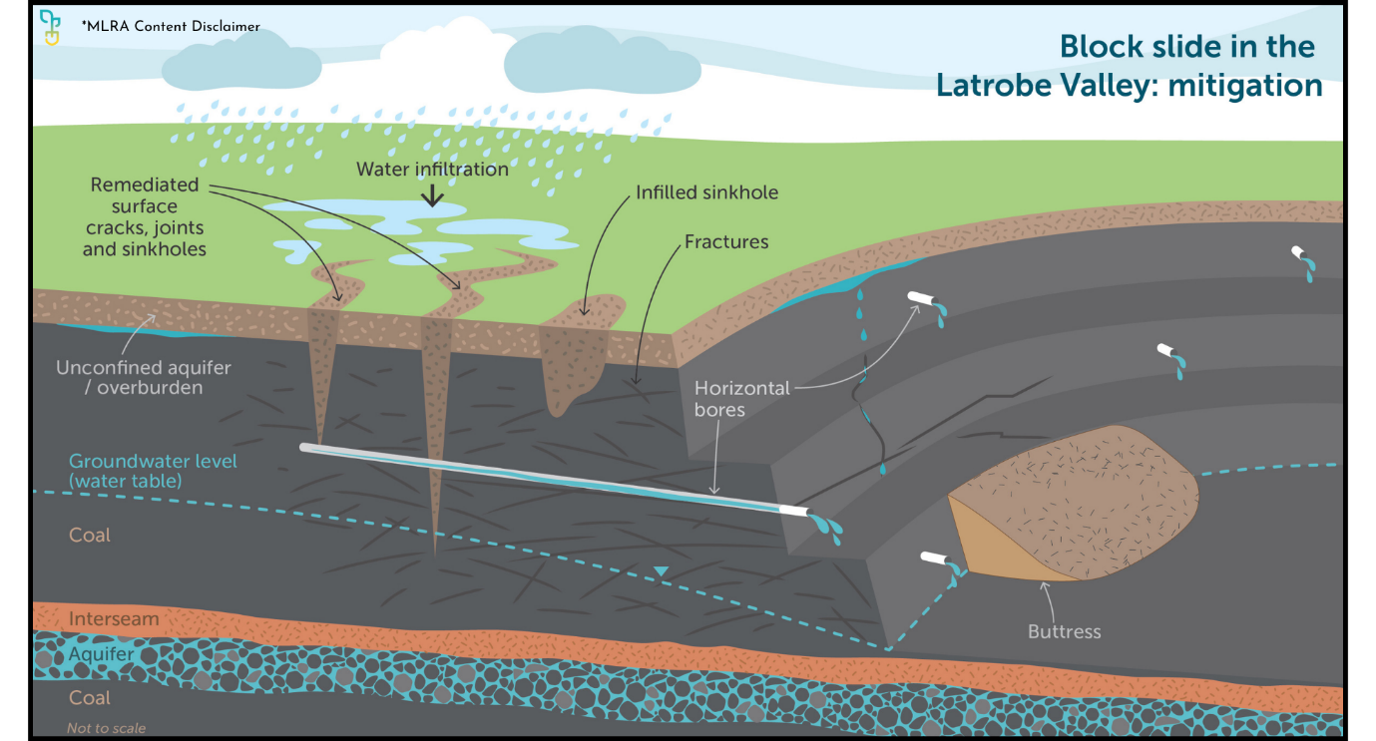

Figure 3

To learn more visit mineland.vic.gov.au.

## Disclaimer:

This content provides the MLRA's high-level overview of aspects of mine rehabilitation in the Latrobe Valley. It does not reflect the opinions, pre-empt decisions or policies of Resources Victoria, mine licensees or any other government department.  The information was accurate to the best of the MLRA's knowledge at the time of publication and is intended to inform the community, stakeholders and Traditional Owners.

 @MLRAuthority  Facebook.com/MLRAVictoria  MLRAuthority