# What are rehabilitation Closure Criteria?

At the end of mine closure activities, before a declared mine license can be surrendered, declared mine licensees are required to meet approved closure criteria. The MLRA defines these as ‘*site specific measures or metrics developed during mine rehabilitation planning against which successful mine closure is determined*’.

## Why do we need them?

Evaluation against criteria is employed internationally by governments and the mining industry, to ensure accountability and demonstrate successful mine rehabilitation. Licensees develop these criteria and government approves them.

Developing and refining criteria allows for the licensees to undertake detailed planning with a targeted goal in mind and helps provide consistency for rehabilitation over timeframes that are expected to last several decades.

Mine licensees can apply to surrender their mining license only once criteria have been met, releasing the successfully rehabilitated site for other land uses.

## How does it all fit together?

Closure criteria form a vital part of closure planning and are a detailed element of the planning framework that starts with the closure vision (Figure 1). Principles and objectives progressively add more detail, allowing site-specific aims to be developed. Criteria are the final measures that demonstrate these aims have been met, and the vision fulfilled. The ICMM Integrated Mine Closure, Good Practice Guideline 2nd Edition provides further information on the closure planning framework.

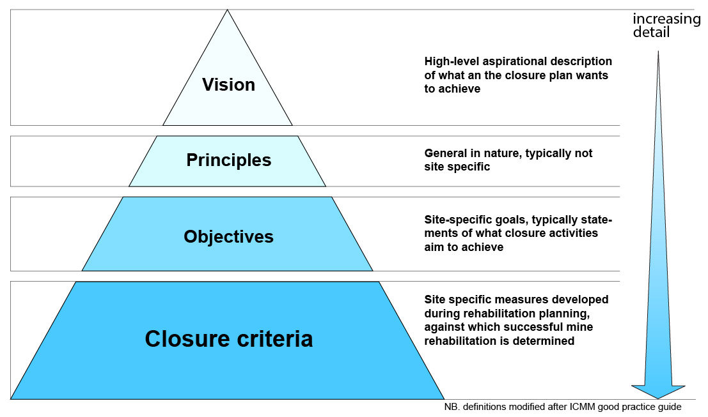

Figure The closure criteria articulate the vision for the site and are site specific

## Closure Criteria in Detail

Closure criteria in Victoria must be S.M.A.R.T. (Specific, Measurable, Achievable, Relevant, Time-bound). Legislation allows for these criteria to be matured over time, as planning advances and site knowledge develops.

The final, approved criteria should demonstrate that the proposed end land uses can be achieved. Criteria should also target key risks and potential long-term controls, demonstrating the successful long-term mitigation, thereby demonstrating the successful rehabilitation.

Examples of criteria may demonstrate that:

* mine batters are stable
* vegetation is self-sustaining and resilient
* water quality is suitable for proposed end land uses

## Who is responsible?

In Victoria, the legislation requires declared mine licensees to develop closure criteria that ensure the site is left ‘safe, stable and sustainable’.

The Minister for Resources will approve the criteria, as part of approving a Declared Mine Rehabilitation Plan (DMRP). This process requires consultation with the MLRA, as well as the Ministers responsible for the following Acts – Crown Land, Environmental Protection, Forests, Land, National Parks, Planning and Environment, Water and Wildlife.

The licensees are responsible for all rehabilitation works in the DMRP, including monitoring to demonstrate successful rehabilitation.

Licensees will apply to the Minister for Resources, who will determine if the criteria are met and if the license can be surrendered. The MLRA will be consulted by the Minister on this decision.

Contact the MLRA for more information on 1800 571 966 or [contactus@mineland.vic.gov.au](mailto:contactus@mineland.vic.gov.au)

 @MLRAuthority  Facebook.com/MLRAVictoria  MLRAuthority