# What is a Monitoring and Evaluation Framework?

The Mine Land Rehabilitation Authority (MLRA) is required to develop and maintain, in consultation with the community, stakeholders, public sector bodies and Latrobe Valley mine licensees, a framework for:

the monitoring and evaluation of the implementation and effectiveness of rehabilitation planning activities and the Latrobe Valley Regional Rehabilitation Strategy (LVRRS); and,

the achieving of the outcomes set out in the Monitoring and Evaluation Framework(); and,

This is in accordance with our requirements under the Mineral Resources (Sustainable Development) Act 1990 (MRSDA) S.84AL(1)(n), S.84AZC & S.84AZD.

Version 1 of the Monitoring and Evaluation Framework was released in 2022. Version 2 has been amended to reflect changes to how we carry out our work and our how we have structured our organisation.

## Who are the stakeholders?

The Monitoring and Evaluation Framework monitors and evaluates the stakeholder groups responsible for declared mine rehabilitation planning and execution. These are:

Owners and operators of the three Latrobe Valley declared mines,

those who have accountability for the LVRRS and

some public sector bodies and regulators.

Other stakeholders, such as community groups and Traditional Owners, must be involved in declared mine rehabilitation planning processes but are not monitored or evaluated, as they are not legally responsible for delivering the plans or outcomes. The MLRA are legislatively required to educate and inform these groups about the rehabilitation of Victoria’s declared mines, this is managed through the MLRA’s Engagement and Education Plan.

## What does the framework focus on?

The MLRA focuses on specific areas with our stakeholders.

For the declared mine licensees these areas include:

the mine licensees’ community engagement

development of their Declared Mine Rehabilitation Plan, and

rehabilitation planning and implementation and

where relevant, the mine licensees’ participation in an Environmental Effects Statement.

For public sector bodies the focus areas include:

monitoring the implementation of the LVRRS

ability of the legislation & policy to be implemented.

community engagement (where relevant)

For each of these the framework outlines:

the key activities that the MLRA will undertake to monitor and evaluate progression,

what the timing of the MLRA activities are and how the MLRA will report on the findings.

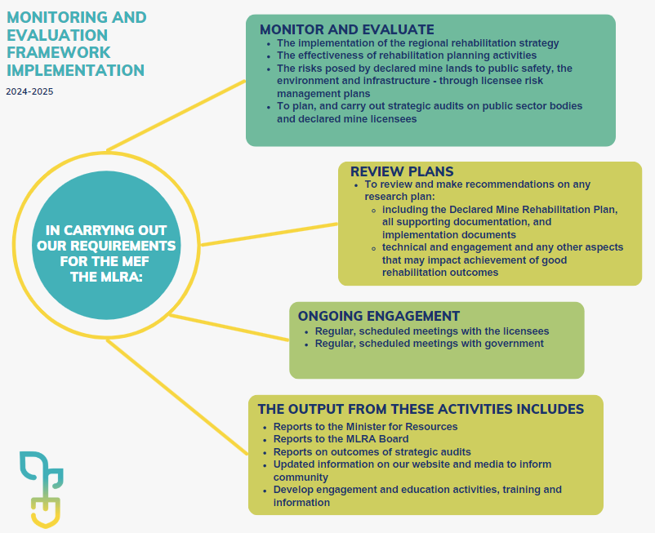

Figure.1: Monitoring and Evaluation Framework Implementation

Contact the MLRA for more information on 1800 571 966 or [contactus@mineland.vic.gov.au](mailto:contactus@mineland.vic.gov.au)

 @MLRAuthority  Facebook.com/MLRAVictoria  MLRAuthority